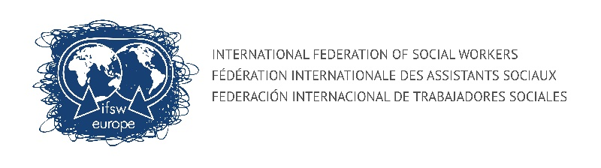 | IFSW Europe e.V. | CONNECTING MEMBERS PROJECT
This project aims to:
> Help to improve communication with members
> Encourage member organizations to become more involved in the work of IFSW
> Support exchange between members
> Encourage new members

COUNTRIES OF EUROPE / EXECUTIVE LINK PERSON

ANA ISABEL  LIMA FERNANDEZ  ifswanalima@gmail.com | SALOME NAMICHEISHVILI  salomeifsw@gmail.com | JOSEFINE  JOHANSSON  josefinejohanson@hotmail.com | MARIA  RÚNARSDÓTTIR  maria@felagsradgjof.is | BRIAN  AUSLANDER  bauslander@gmail.com | TANJA  KATKIC  tanjakst@gmail.com

Andorra | Armenia | Belarus | Iceland | Austria | Albania
France | Azerbaijan | Denmark | Ireland | Belgium | Bosnia and Herzegovina
Italia | Bulgaria | Estonia | Czech Republic | Germany | Croatia
Monaco | Georgia | Faroe Islands | Hungary | Israel | Cyprus
Portugal | Moldova | Finland | Slovakia | Luxemburg | Greece
San Marino | Romania | Latvia | Poland | The Netherlands | Kosovo
Spain | Turkey | Lithuania | UK | Switzerland | Macedonia
 | Ukraine | Norway |  |  | Montenegro
 | Russia | Sweden

