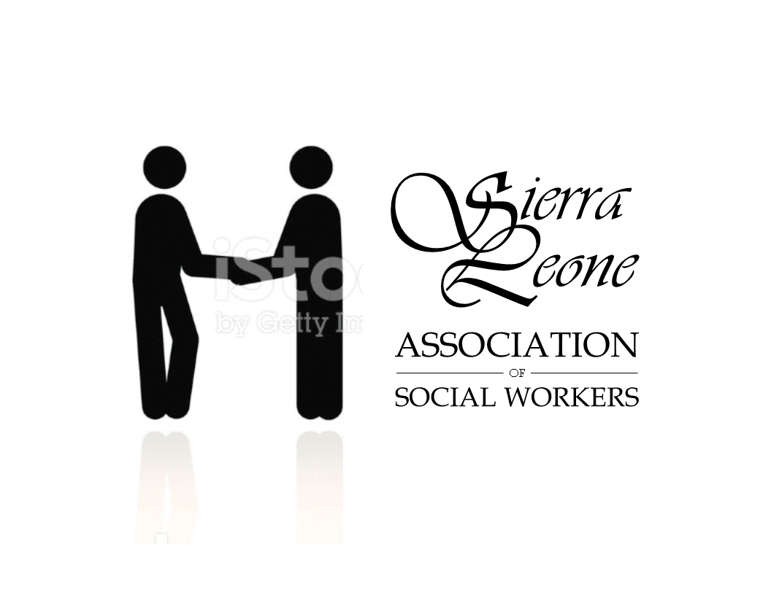
7th Nov., 2016
The President
International Federation of Social Work
Africa regional office

Dear Sir,
Application for IFSW Membership
I am pleased on behalf of the Sierra Leone association of social workers to apply for membership to the international federation of social work. This is to join the global family in meeting the needs of vulnerable and marginalized individuals and groups in the communities we serve and to build a sustainable foundation for the social work profession to thrive.
I herewith present our associations’ constitution and code of ethics which we vow to uphold, a list of the executive members and the concept note for your consideration. I am on behalf of the association therefore looking forward to your acknowledgement of our application. Thanking you in advance as together we are strong.
Warmest regards,
Yours faithfully,
...............................
George Mansaray
President
Kiradi Initiatives Sierra Leone [kISL]
Concept note:
Establishing the Sierra Leone association of social workers
Introduction:
Kiradi initiative is a community based organisation that strives for the protection of the basic human rights of vulnerable people and promoting the concept of education for sustainable development in Sierra Leone.
Its membership is made up of social workers, teachers, nurses and other paraprofessionals who function as a formidable team of volunteers to serve humanity. Over its years of diligent service to its clientele, it realised that there are gaps that require a national team with dedication and commitment to fill those gaps.
Some of the identified gaps to outline but a few include the following: the absence of an association for the past three decades to steer the affairs of social workers, no national code of ethics, no license or registry system for social workers, no clear cut structure or framework for social workers in social services delivery, service delivery institutions are inadequate and where available are wrought with abuse and lots of inadequacies, professional training at degree level has been introduced across universities and young social work graduates are graduating with no guide or a frame work to help them stand out as paraprofessionals in their field, interagency collaboration is not seen.
The Kiradi initiative based on its identified gaps initiated the idea of ‘establishing the sierra Leone association of social workers’ to provide a platform to manage the affairs of social workers from a central hub, enlisting individual, family, community and the governments support to engender change by putting in place the structures, procedures and processes for social workers to render professional services to its clientele for sustainable living, practices and futures.

Background:
A complex and broad concept, social work is to enhance human wellbeing and help meet the basic human needs of all people with particular attention to the need and empowerment of people who are vulnerable, oppressed and living in poverty.
For over three decades, the social work profession had no organized professional body that stood out to helping citizens to understand and act upon issues that concerns their welfare and the environment they live. However, despite individual and smaller group efforts to render professional social service, progress has been slow. Current social work services relating to individuals, groups and communities tend to be inadequate and in most cases unavailable and infringes on the social work code of ethics. Moreover, the authorities understanding of these vital themes most times depend on the dedication and preparedness of the social workers who are unlikely to be specialized in this particular area.
Although a significant proportion of these themes may be addressed in agriculture, human right and health, social work has much potential as a unique profession. Such an approach would allow authorities to understand the connection between the initial issues and their consequences, and to identify the most suitable solutions.
Given that universities had of recent introduced degree courses in social work, and are a viable option for a minority of young people, we are initially focussing our efforts on building a solid foundation for them to thrive. We believe that putting the structures in place now will have the most important effects on society and the futures of social work in Sierra Leone.
The earlier we can build coherent structures and systems about social work and its ethical practice, the better; given that today’s young social workers will be tomorrows experts/professionals, their engagement in national social service delivery
and improved understanding of social work will surely be a positive step for the future.

Our approach:
We work with every category of social workers, teachers, nurses, community based organisations organizing events such as radio talk shows, meetings with student social workers, social services department and personal contacts which promote knowledge about the association.
From this base, we aim to enter into a dialogue with ministries, departments and agencies in order to advocate for a legal functional structure and framework for social work to stand out.
Our work so far:
The Sierra Leone association of social workers was conceived in September 2015. The projects preparatory phase was conceived in may 2016; extensive research was conducted on the functionality of social work as a profession.
A network of partners, local experts, communities, and community based organisations was developed. We are yet in the content phase development.
We are in contact with the IFSW Africa region president and the relationship is cordial and had been very supportive, we have a face book file and an article – Global compassion- social services in Sierra Leone- courtesy of Michael Giles-medical social worker USA, a logo courtesy of Mark, met colleagues online that are very supportive to put us right. In first week of November, we elected the executive and working closely with colleagues around the globe doing bits to get us up and running.
Recommendations:
This document does not aim to propose the specific details of establishing an association of social workers itself; this task will instead require the concerted efforts of local and international social workers, social work institutions, a skills base which the team does not pretend to have.
However, below we list our recommendations as to the scope and structure of the idea:
Given the multi-faceted nature of the idea as outlined for the establishing of the association, it should not only include registering as a national association and joining the international federation, but also a focus on the equally important, but sometimes overlooked aspects of capacity building ensuring social workers in Sierra Leone engage in ongoing professional development.
We aim to ensure that the social work profession takes its right place in our society by facilitating interagency collaboration, putting the procedures and processes right, ensuring for a national code of ethics and promoting awareness on the contributions of social work to society.
To ensure the representation of the views of social workers on matters of social policy and practice at local and international level
To provide support to social workers in the practice of the profession
Considering the country’s poor economic standings and the inadequacies in service delivery, specific projects will be incepted to ensure for service centres to be established and where already established but not functional will be revived.
Anticipated benefits:
The establishment of the association brings benefits not only to its membership but through their training and attitude to many sectors of society. We see the anticipated benefits to bring:
Increased interagency engagement resulting in active participation in putting the social services structures in place and make them functional
Increased awareness on social work issues in society and will know what to do and where to go when the need arises
In the long run, a decrease in social services challenges due to a more informed and responsible attitude among the people
Available social service system relevant to the Current realities and challenges posed by the society providing adequate and appropriate services
Policies that would highlight governments’ willingness to render more quality services to tackle challenges
THE NATIONAL EXECUTIVE COMMITTEE
Under listed are names of the elected members to the national executive committee:
Mr. George Mansaray – President
Ms. Eleanor Massah Abdulai – Vice President
Mr. Edward Jimmy – Secretary General
Mrs. Fatmata Turay – Assistant Secretary General
Mr. Mustapha Morba Sheku Turay – Treasurer

THE BOARD OF TRUSTEES
Ms. Fatmata Kontha kamara
Ms. Patricia Alie Kamara
Mr. Oathman Zainu
Mr. Richard Foday Kamara - Patron
Mr. Sahr Albert Yarjah

